**Functional Requirement Specification**

_______________________________________________________________________________________

***Attendance***

***System***

**By IT Department, Kerjaya Prospek Sdn. Bhd.**

28th March 2025

**Version Control**

|  |  |  |  |
| --- | --- | --- | --- |
| **Version** | **Release Date** | **Update By** | **Remarks** |
| v1.0 | 28/3/2025 | Nurul Hazimah | Initial Document |

Table of Contents

1. Introduction 5

1.1. Purpose of This Document 5

1.2. Intended Audience and Reading Suggestions 5

1.3. Document Conventions 5

1.4. Project Objective 5

2. Project Detail 6

3. User Matrix 7

4. Module 8

5. Process Flow 11

5.1. Create or Staff/Worker/Leader information 11

5.2. Create Subcon Company 12

5.3. Deactivate worker 12

5.4. Create Salary worker salary rate & OT rate 13

5.5. Create Salary Advance/Loan request 14

5.6. Create pre/post payment request 14

5.7. Assign OT & Special Hours 15

5.8. Create worker shifting 16

5.9. Create Debit Note / Credit Note 16

5.10. Create Requisition 17

6. Field Index 20

6.1. Create New Worker 20

6.2. Create New Staff 22

6.3. Create Leader 24

6.4. Create Team 24

6.5. Create Subcon Company 25

6.6. Create worker Deactivation 25

6.7. Create Salary worker salary rate & OT rate 26

6.8. Salary Advance or Loan request 27

6.9. PrePost Salary Payment Request 28

6.10. Assign OT & Special Hours 29

6.11. Create worker shifting 30

6.12. Create Debit Note 30

6.13. Create Credit Note 31

6.14. Create Requisition 31

7. Configurations page 33

7.1. User Setting 33

7.2. IT Setting 33

8. Retention years 33

9. Appendix 34

9.1. New Checkout Rules Effective 01 Dec 2023 34

# Introduction

## Purpose of This Document

This document aims to provide requirements specifications for bridging the gap between the business requirements and the implementation solution. This document will cover the system’s intended functionalities and other technical dependencies.

## Intended Audience and Reading Suggestions

This document is intended for all individuals participating in the project.

Readers interested in a brief overview may refer to Section 1 which covers the introduction of the project objectives.

Readers interested in detail on requirements and dependencies should read on to Section 2 which expands upon the technical information laid out in the implementation solution.

## Document Conventions

This document uses the following conventions.

|  |  |
| --- | --- |
| **Acronym** | **Context** |
| RF | Requisition |
| DN | Debit Note |
| CN | Credit Note |
| SL | Sub Labour |
| DSC | Domestic Subcon |
| NSC | Nominated Subcon |
| SDNR | Site Debit Note Request |
| DN | Debit Note |
| CN | Credit Note |

## Project Objective

To revamp the existing attendance system by transforming it into a more user-friendly and updated version.

# Project Detail

This project aims to revamp the user interface and user experience of this Attendance System. There are total of 12 parent module (*these module will be increase from time to time) with submodules for each modules. Below is the information of parent and submodules that has been revised according from current system.

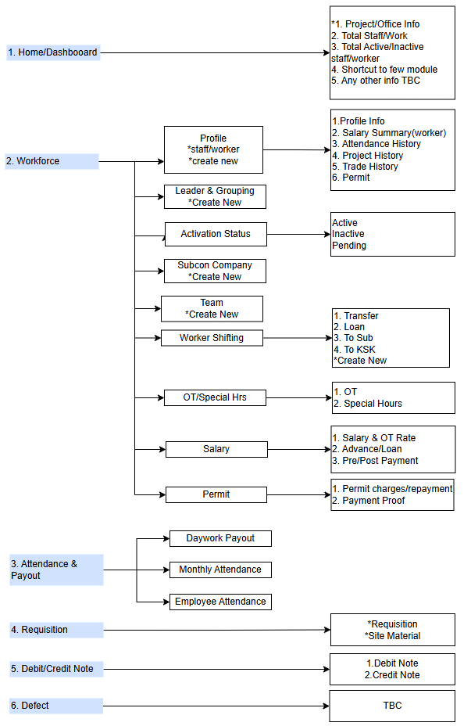 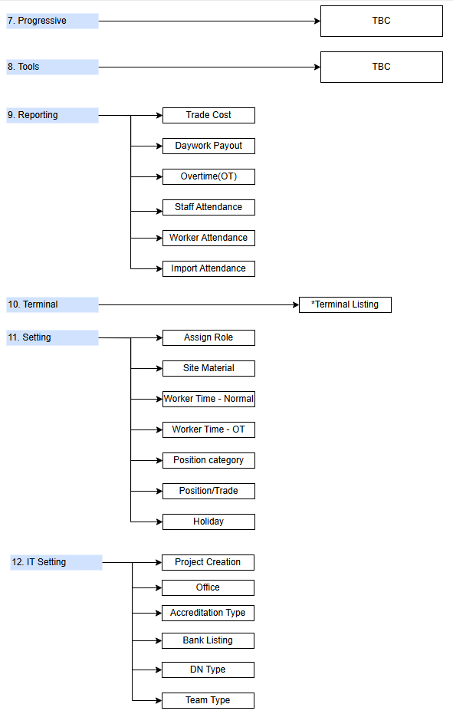

# User Matrix

|  |  |  |
| --- | --- | --- |
| **No.** | **Role** | **Description** |
| 1 | Site Admin | Site Admin only can manage the information of their site/projects only   1. Create & update worker/staff/subcon info for projects 2. Create RF/DN/CN 3. Create & update worker salary rate/OT Rate/loan request |
| 2 | HR Admin | 1. Create staff for office/tenants |
| 4 | Account | 1. Approval DN/CN |
| 5 | QS | 1. Create DN/CN 2. Create & update Permit charges/repayment |
| 6 | Purchasing | 1. Approval DN/CN 2. Create Material Item |
| 7 | Manager | 1. Approval DN/CN |
| 8 | Director | 1. Approval DN/CN |
| 9 | Superadmin | 1. Create Project/Office/Tenant |



# Module

|  |  |  |  |
| --- | --- | --- | --- |
| **Parent Module** | **Sub Module** | **Description** | **Role access** |
| Home | N/A | Home modules will show the details as below: -  1. Project/Office Info 2. Total Staff/Work  3. Total Active/Inactive staff/worker  4. Shortcut to few module  5. Any other info TBC | All |
| Workforce | Profile | There will be listing of staff/worker of the project with below details information   1. Basic Profile Info 2. Salary Summary (only applicable for worker) 3. Attendance History 4. Project History 5. Trade History 6. Permit | Site Clerk |
| Deactivate worker | Manage worker deactivation | Site Clerk |
| Worker Leader | Manage of leader for SL & KSK worker | Site Clerk |
| Subcon Company | Manage subcon company (DSC/NSC) | Site Clerk |
| Team | Manage team for each project | Site Clerk |
| Worker Shifting | Manage the worker shifting based on 4 categories   1. Transfer – To transfer worker to another project 2. Loan – To loan worker to another project 3. To SL – To transfer worker to SL worker type 4. To KSK – To transfer worker to KSK worker type | Site Clerk |
| OT/Special Hrs | Manage the OT and Special Hours for workers | PIC |
| Salary | Manage the worker salary as below   1. Salary & OT Rate 2. Advance/Loan 3. Pre/Post payment | Site Clerk |
| Permit | Manage the permit as below   1. Permit charger or repayment 2. Payment proof | QS |
| Attendance & Paywork | Daywork Payout | Daywork Payout reporting for each worker.  KSK – Daywork payout by Project  SL – daywork Payout by Trade in Project | HR Admin |
| Monthly Attendance | Information of monthly attendance for the selected project | HR Admin |
| Employee Attendance | Information of employee attendance by selected project | HR Admin |
| Requisition | Requisition | Manage worker material requisition | QS  Site Clerk  PIC  Account |
| Debit/Credit Note | Debit Note | Manage worker debit note  *Debit note: debit worker because of doing something that is not right during working | QS  Site Clerk  PIC |
| Credit Note | Manage worker credit not | QS  Site Clerk  PIC |
| Defect | Defect | Manage the defect lodge by customer |  |
| Progressive | Progressive | Manage the progressive of development |  |
| Tools | Tools | TBC |  |
| Reporting (applicable for projects only) | Trade Cost | Report of trade cost by monthly basis | Site Clerk |
| Daywork Payout | Daywork Payout reporting for each worker.  KSK – Daywork payout by Project  SL – daywork Payout by Trade in Project | Site Clerk |
| Worker Overtime (OT) | Report of OT worker from date selected | Site Clerk |
| Staff Attendance | Report of staff attendance for project | Site Clerk |
| Worker Attendance | Report of worker attendance for project | Site Clerk |
| Import Attendance | TBC | Site Clerk |
| Terminal | Terminal | Manage the terminal system (on/off) | Site Clerk |
| Setting | Assign Role | Manage the roles in the system | Site Clerk |
| Site Material | Manage the site material for requisition | Site Clerk |
| Worker Time – OT | Manage the OT Time for worker | Site Clerk |
| Worker Time - Normal | Manage the normal working time for  worker | Site Clerk |
| Position Category | Manage the position category | Site Clerk |
| Position/Trade | Manage position/trade category | Site Clerk |
| Holiday | Manage holiday | Site Clerk |
| IT Setting | Project/Office Creation | Manage the project/office creation | Superadmin |
|  | Accreditation Type | Manage accreditation type | Superadmin |
|  | Bank Listing | Manage bank listing | Superadmin |
|  | DN Type | Manage DN Type | Superadmin |
|  | Team Type | Manage Team Type | Superadmin |

# Process Flow

## Create or Staff/Worker/Leader information

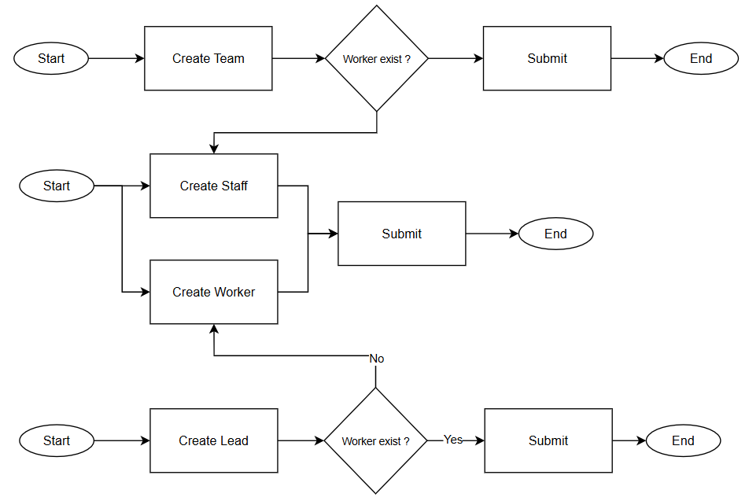

|  |  |  |  |
| --- | --- | --- | --- |
| **No.** | **Stage** | **Description** | **Action** |
| 1 | Create Staff | User required to fill in details needed.  Refer to Field Index for detail. | * Submit |
| 2 | Create Worker | User required to fill in details needed.  Refer to Field Index for detail. | * Submit |
| 3 | Create Worker Lead | User required to fill in details needed. If the worker name is not in the listing, user required to create worker first. | * Submit |
| 3 | Create Team | User required to fill in details needed. If the staff name is not in the listing, user required to create staff first. | * Submit |

## Create Subcon Company

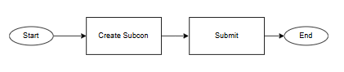

|  |  |  |  |
| --- | --- | --- | --- |
| **No.** | **Stage** | **Description** | **Action** |
| 1 | Create Subcon Company | User required to fill in details needed.  Refer to Field Index for detail. | * Submit |

## Deactivate worker

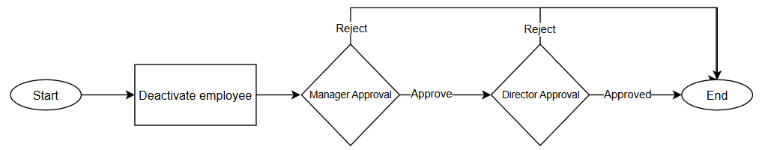

|  |  |  |  |
| --- | --- | --- | --- |
| **No.** | **Stage** | **Description** | **Action** |
| 1 | Deactivate worker | User required to select worker and fill in the info needed. System allow user to deactivate more than one worker in one submission up to 20 workers  User allow to save before submitted the application. The information will save as Draft up to 60 days. | * Save * Submit |
| 2 | Manager & Director Approval | Once application submitted, the information will to Manager followed by director for approval. If one of the approver rejected the application, the process will end else, the application approved and the worker status is deactivate | * Approve * Reject |

## Create Salary worker salary rate & OT rate

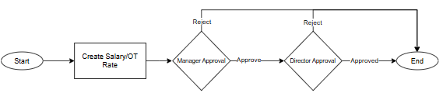

|  |  |  |  |
| --- | --- | --- | --- |
| **No.** | **Stage** | **Description** | **Action** |
| 1 | Deactivate worker | User required to select worker and fill in the info needed. System allow to select more than one worker in one submission up to 20 workers  User allow to save before submitted the application. The information will save as Draft up to 60 days. | * Save * Submit |
| 2 | Manager & Director Approval | Once application submitted, the information will to Manager followed by director for approval. If one of the approver rejected the application, the process will end else, the application approved and the worker status is deactivate | * Approve * Reject |

## Create Salary Advance/Loan request

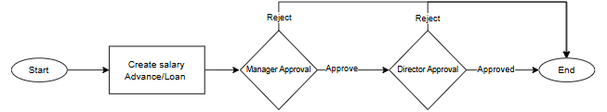

|  |  |  |  |
| --- | --- | --- | --- |
| **No.** | **Stage** | **Description** | **Action** |
| 1 | Deactivate worker | User required to select worker and fill in the info needed. System allow user to deactivate more than one worker in one submission up to 20 workers  User allow to save before submitted the application. The information will save as Draft up to 60 days. | * Submit |
| 2 | Manager & Director Approval | Once application submitted, the information will to Manager followed by director for approval. If one of the approvers rejected the application, the process will end else, the application approved | * Approve * Reject |

## Create pre/post payment request

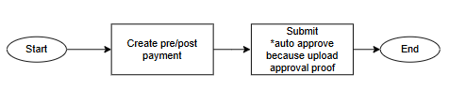

|  |  |  |  |
| --- | --- | --- | --- |
| **No.** | **Stage** | **Description** | **Action** |
| 1 | Pre/post payment request | User required to select the payment type and fill in the info needed. User need to provide the approval document to proceed with the application. System allow user to add more than one worker in one submission up to 20 workers.  *Once submitted, status auto Approve as the approval already happened outside the system. | * Submit |

## Assign OT & Special Hours

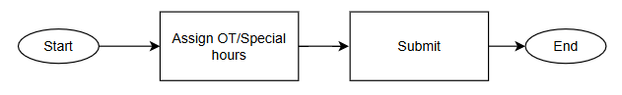

|  |  |  |  |
| --- | --- | --- | --- |
| **No.** | **Stage** | **Description** | **Action** |
| 1 | Assign OT & Special Hours | User required to select the type and fill in the info needed.  *Once submitted, system will only acknowledge the salary of worker that has been assign from the team. | * Submit |

## Create worker shifting

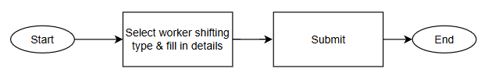

|  |  |  |  |
| --- | --- | --- | --- |
| **No.** | **Stage** | **Description** | **Action** |
| 1 | Worker Shifting | User required to select worker shifting type (Transfer/Loan/To Sub/To KSK) and fill in the info needed. System allow user to select multiple worker from the worker list  Once worker selected, their name will be auto on the top of the list to ensure user can con view the workers selected accordingly | * Submit |

## Create Debit Note / Credit Note

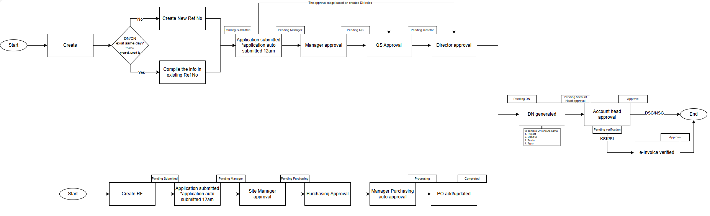

|  |  |  |  |
| --- | --- | --- | --- |
| **No.** | **Stage Name & Role** | **Description** | **Action** |
| 1 | Create SDNR | User required to fill in details needed. If the project & debit to is the same worker SDNR that has been created on the same, the SDNR will be compile together.  Once user click Submit, system will save the application first and auto submitted at 12AM. | * Submit |
| 2 | DSNR approval | Once DSNR submitted, the information will to Manager followed by QS and Director for approval. If one of the approvers rejected the application, the process will end else, the application approved.  However, the approval process will be depends on the roles. For example, if the submitter is manager, it will skip manager approval and direct to QS manager. | * Approve * Reject |
| 3 | Create DN | Once Director approve DN, Account user will create DN. If the SDNR have the same information for project, debit to, trade & type the SDNR can be compile into a DN. | * Generate DN |
| 4 | DN approval | Once DN submitted, the DN now pending for Head of account approval. If the type is KSK or SL, the DN status become approve after Head of account approval. If the type is DSC or NSC, the status become pending verification for account staff to upload the e-Invoice certificate. Once uploaded, DN status become Approve | * Approve * Reject |

## Create Requisition



|  |  |  |  |
| --- | --- | --- | --- |
| **No.** | **Stage Name & Role** | **Description** | **Action** |
| 1 | Create RF | User required to fill in details needed.  Once user click Submit, system will save the application first and auto submitted at 12AM. | * Submit |
| 2 | RF Approval | Once RF submitted, the application will go to Site Manager followed by Purchasing. Once Purchasing approved, the Purchasing Manager will auto approve the application. If one of the approvers rejected the application, the process will end else, the application approved.  At this point, SDNR reference number auto created and included in SDNR listing. | * Approve * Reject |
| 3 | PO add/update | After the approval stage, purchasing required to add or update PO for this RF. Once Po updated, RF status becomes completed. | * Save * Submit |
| 4 | Create DN | Once Director approve DN, Account user will create DN. If the SDNR have the same information for project, debit to, trade & type the SDNR can be compile into a DN. | * Generate DN |
| 5 | DN approval | Once DN submitted, the DN now pending for Head of account approval. If the type is KSK or SL, the DN status become approve after Head of account approval. If the type is DSC or NSC, the status becomes pending verification for account staff to upload the e-Invoice certificate. Once uploaded, DN status become Approve | * Approve * Reject |

# Field Index

## Create New Worker

|  |  |  |  |  |  |  |
| --- | --- | --- | --- | --- | --- | --- |
| **No** | **Index** | **Field Type** | **Index Type** | **Required** | **Remarks** | **Example** |
| **Personal Info** | | | | | | |
| 1 | Name | User Input | String(100) | Yes | Input Manually - word | Mohd Noor bin Azman |
| 2 | Nickname | User Input | String(10) | No | Input Manually - word | Azman |
| 3 | Photo | User Inpur | Image(420px*540px) | Yes | Upload Manually | N/A |
| 4 | Sex | User Input | Listing | Yes | Select from list | Yes, No |
| 5 | Nationality | User Input | Listing | Yes | Select from list | *List of country |
| 6 | Race | User Input | Listing | No | Select from list | Malay, Chinese, Indian, Indo, Others |
| 7 | Religion | User Input | Listing | No | Select from list | Muslim, Buddhist, Hindu, Taoism, Others |
| 8 | Mobile No | User Input | String (15) | Yes | Input Manually - number | 0123456789 |
| **Work Info** | | | | | | |
| 1 | ID | User Input | String(10) | No | Input Manually - number | Mohd Noor bin Azman |
| 2 | Trade | User Input | Listing | Yes | Select from list | *List of trade from Setting |
| 3 | Project Name | User Input | Listing | Yes | Select from list | *List of Project Name |
| 4 | Worker Type | User Input | Radio button/dropdown | Yes | Select from list | KSK, SL, DSC, NSC |
| 5 | Group(KSK/SL) **OR**  Subcon (DSC/NSC) | User Input | Listing | Yes | Select from list *Required to select Project Name & Worker Type first *KSK/SL- Listing based of Leader or grouping from Leader & Grouping Module of the project DSC/NSC - Listing based on company listing from xx module of the project | KSK - KSK TC Operator SL - Ali(Screeding & Corner Bead) DSC - Azlan Enterprise(Tower Crane) NSC - SYT Engineering SDN. BHD(Smart Home system) |
| 6 | Team | User Input | Listing | Yes | Select from list *Team grouping listing by project | Format : Team Type-TeamName-Team Supervisor |
| 7 | Friday Prayer | User Input | Radio button/dropdown | Yes | Select from list | Yes/No |
| 8 | Joined Date | User Input | Date | No | Select from calender | Format : mm/dd/yy |
| 9 | Introducer | User Input | String(100) | No | Input Manually - word | Azlan |
| 10 | Email | User Input | String(100) | No | Input Manually - word | email format : abc@gmail.com *@ is compulsary |
| 11 | Origin Type | User Input | Listing | No | Select from list | KSK, SL, DSC, NSC |
| Identififcation Info | | | | | | |
| **Certification Info** | | | | | | |
| **1** | Certification Type | User Input | Listing | Yes | Select from list | IC, Passport |
| 1 | IC(Certification type=IC) **OR** Passport(Certification type=IC) | User Input | String | Yes | Input Manually *If Nationality = Malaysia then index = IC else Passport | IC: 652012-08-5631 Passport: A00000000 |
| 2 | Passport Expiry | User Input | Date | Yes is Nationality ≠ Malaysia | Select from calender | Format : mm/dd/yy |
| 3 | IC copy(Certification type=IC) **OR** Passport copy(Certification type=IC) | User Input | Document/Image | Yes | Upload Manually *same condition as Certification Info Number 1 | N/A |
| **CIDB** | | | | | | |
| **1** | CIDB No | User Input | String(12) | No | Input Manually | Format: 12 digit number 112345678912 |
| **2** | CIDB Expiry Date | User Input | Date | No | Select from calender | Format : mm/dd/yy |
| **3** | CIDB Cert | User Input | Document/Image | No | Upload Manually | N/A |
| **Permit** | | | | | | |
| **1** | Permit Type | User Input | Listing | No | Select from List | KP, Sl, DSC/NSC, Pending Doc, Others |
| **2** | Permit No | User Input | String(20) | No | Input Manually | A123456789 |
| **3** | Permit Expiry Date | User Input | Date | No | Select from calender | Format : mm/dd/yy |
| **4** | Permit Copy | User Input | Document/Image | No | Upload Manually | N/A |
| **Accreditation** | | | | | | |
| **1** | Accreditation Type | User Input | Listing | No | Select from List | *List of Accreditation Type |
| **2** | Accreditation No | User Input | String(20) | No | Input Manually | QS 02121999 CB 01 |
| **3** | Accreditation Date | User Input | Date | No | Select from calender | Format : mm/dd/yy |
| **4** | Accreditation Copy | User Input | Document/Image | No | Upload Manually | N/A |
| **Socso** | | | | | | |
| 1 | Socso No | User Input | String(20) | No | Input Manually |  |
| **EPF** |  |  |  |  |  |  |
| 1 | EPF No | User Input | String(20) | No | Input Manually |  |
| **Income Tax** | | | | | | |
| 1 | Tax No | User Input | String(20) | No | Input Manually |  |
| **Salary Payment** | | | | | | |
| 1 | Payment Type | User Input | Listing | Yes | Select from List | Cash, Bank, TNG eWallet |
| 2 | Phone No(Payment Type= TNG eWallet) **OR** Account No(Payment Type=Bank) | User Input | String | Yes if user select Bank **OR** TNG eWallet | Select from List | Account No: 1001021452 Phone No: 011234567894 |
| 3 | Bank Name | User Input | String(20) | Yes is user select Payment Type = Bank | Select from List | *List of Bank in Malaysia |

## Create New Staff

|  |  |  |  |  |  |  |
| --- | --- | --- | --- | --- | --- | --- |
| **No** | **Index** | **Field Type** | **Index Type** | **Required** | **Remarks** | **Example** |
| **Personal Info** | | | | | | |
| 1 | Name | User Input | String(100) | Yes | Input Manually - word | Mohd Noor bin Azman |
| 2 | Nickname | User Input | String(10) | No | Input Manually - word | Azman |
| 3 | Photo | User Inpur | Image(420px*540px) | Yes | Upload Manually | N/A |
| 4 | Sex | User Input | Listing | Yes | Select from list | Yes, No |
| 5 | Nationality | User Input | Listing | Yes | Select from list | *List of country |
| 6 | Race | User Input | Listing | No | Select from list | Malay, Chinese, Indian, Indo, Others |
| 7 | Religion | User Input | Listing | No | Select from list | Muslim, Buddhist, Hindu, Taoism, Others |
| 8 | Mobile No | User Input | String (15) | Yes | Input Manually - number | 0123456789 |
| **Work Info** | | | | | | |
| 1 | Staff ID | User Input | String(10) | Yes | Input Manually - number | Mohd Noor bin Azman |
| 2 | Worker Type | User Input | Listing | Yes | Select from list | KSK, SL, DSC, NSC |
| 3 | Office(Worker Type=KSK) or Subcon(Worker Type = SL/DSC/NSC) | User Input | Listing | Yes | Select from list *Select from Office/subcon listing | HQ KPM |
| 4 | Cost Center | User Input | Listing | Yes | Select from list *Select from List of Project | Aintech |
| 5 | Project/s | User Input | Listing | Yes | Select from list *Select from List of Project *multiple selection allowed | Aintech Astrum |
| 6 | Position Category | User Input | Listing | Yes | Select from list | *Select from Position Category Advertising and Promotion |
| 7 | Position | User Input | Listing | Yes | Select from list *Select listing based on Position selected | Assistant Advertising and Promotion |
| 8 | Joined Date | User Input | Date | No | Select from calender | Format : mm/dd/yy |
| 9 | Admin Role | User Input | Listing | Yes | *Default as No | Yes No |
| 10 | Card SN | User Input | String | Yes | Input Manually | ABC12345678 |
| Identififcation Info | | | | | | |
| **Certification Info** | | | | | | |
| 1 | Certification Type | User Input | Listing | Yes | Select from list | IC, Passport |
| 2 | IC(Certification type=IC) **OR** Passport(Certification type=IC) | User Input | String | Yes | Input Manually *If Nationality = Malaysia then index = IC else Passport | IC: 652012-08-5631 Passport: A00000000 |
| 3 | Passport Expiry | User Input | Date | Yes is Nationality ≠ Malaysia | Select from calender | Format : mm/dd/yy |
| 4 | IC copy(Certification type=IC) **OR** Passport copy(Certification type=IC) | User Input | Document/Image | Yes | Upload Manually *same condition as Certification Info Number 1 | N/A |
| **CIDB** | | | | | | |
| **1** | CIDB No | User Input | String(12) | No | Input Manually | Format: 12 digit number 112345678912 |
| **2** | CIDB Expiry Date | User Input | Date | No | Select from calender | Format : mm/dd/yy |
| **3** | CIDB Cert | User Input | Document/Image | No | Upload Manually | N/A |
| **Permit** | | | | | | |
| **1** | Permit Type | User Input | Listing | No | Select from List | KP, Sl, DSC/NSC, Pending Doc, Others |
| **2** | Permit No | User Input | String(20) | No | Input Manually | A123456789 |
| **3** | Permit Expiry Date | User Input | Date | No | Select from calender | Format : mm/dd/yy |
| **4** | Permit Copy | User Input | Document/Image | No | Upload Manually | N/A |
| **Accreditation** | | | | | | |
| **1** | Accreditation Type | User Input | Listing | No | Select from List | *List of Accreditation Type |
| **2** | Accreditation No | User Input | String(20) | No | Input Manually | QS 02121999 CB 01 |
| **3** | Accreditation Date | User Input | Date | No | Select from calender | Format : mm/dd/yy |
| **4** | Accreditation Copy | User Input | Document/Image | No | Upload Manually | N/A |

## Create Leader

|  |  |  |  |  |  |  |
| --- | --- | --- | --- | --- | --- | --- |
| **No** | **Index** | **Field Type** | **Index Type** | **Required** | **Remarks** | **Example** |
| 1 | Worker Type | User Input | Listing | Yes | Select from list | KSK, SL |
| 2 | Lead | User Input | Listing | Yes | Select from list | Format: WorkerName Passport No |
| 3 | Group Name | Auto Lookup | String(100) | Yes | Input Manually - word | Worker Name |
| 4 | Passport | Auto Lookup | String(15) | Yes | Input Manually - word | Passport No |
| 5 | SL Name | Auto Lookup | String(100) | Yes | Input Manually - word | Worker Name |

## Create Team

|  |  |  |  |  |  |  |
| --- | --- | --- | --- | --- | --- | --- |
| **No** | **Index** | **Field Type** | **Index Type** | **Required** | **Remarks** | **Example** |
| 1 | Team Type | User Input | Listing | Yes | Select from list | KSK, SL |
| 2 | Team Name | User Input | Listing | Yes | Select from list | Format: WorkerName Passport No |
| 3 | Supervisor | Auto Lookup | String(100) | Yes | Input Manually - word | Worker Name |
| 4 | Assistant | Auto Lookup | String(15) | Yes | Input Manually - word | Passport No |
| Worker | | | | | | |
| 1 | N/A *Appear list of worker with details for this projects | Auto Lookup | Listing | Yes | Select workers for this project from the list *Allow multiple selection | *Tick at selected worker |

## Create Subcon Company

|  |  |  |  |  |  |  |
| --- | --- | --- | --- | --- | --- | --- |
| **No** | **Index** | **Field Type** | **Index Type** | **Required** | **Remarks** | **Example** |
| 1 | Company Name | User Input | String(50) | Yes | Input Manually - word | ABC Sdn Bhd |
| 2 | Formerly Known as | User Input | String(50) | No | Input Manually - word | BCD Sdn Bhd |
| 3 | Company Reg No | User Inpur | String(15) | Yes | Input Manually - word | A00001 |
| 4 | Type | User Input | Listing | No | Select from list | Domestic(DSC), Nominated(NSC) |
| 5 | PIC Name | User Input | String(100) | No | Input Manually - word | Ahmad bin Ali |
| 6 | Contact No | User Input | String(15) | No | Input Manually - number | 01123456789 |
| 7 | Email | User Input | String(30) | No | Input Manually - word | [abc@gmail.com](mailto:abc@gmail.com) |
| 8 | Address 1 | User Input | String(50) | No | Input Manually - word | lorong 10, |
| 9 | Address 2 | User Input | String(50) | No | Input Manually - word | Puchong Centre |
| 10 | City | User Input | String(50) | No | Input Manually - word | Puchong |
| 11 | Postcode | User Input | Listing | No | Select from list | 35410 |
| 12 | State | User Input | Listing | No | Select from list *Listing of state in malaysia | Wilayah Perseketuan Kuala Lumpur |
| 13 | TIN No | User Input | String(10) | No | Input Manually - word | C20830570210 |
| 14 | Vendor Code | User Input | String(10) | No | Input Manually - word | 111223344 |
| 15 | Company logo | User Input | Image(420px*540px) | No | Upload Manually | N/A |

## Create worker Deactivation

|  |  |  |  |  |  |  |
| --- | --- | --- | --- | --- | --- | --- |
| **No** | **Index** | **Field Type** | **Index Type** | **Required** | **Remarks** | **Example** |
| 1 | Worker | User Input | Listing | Yes | Select from the list | Ahmad Ali |
| 2 | IC/Passport | Auto lookup from Worker | N/A | N/A | N/A | E34324 |
| 3 | ID | Auto lookup from Worker | N/A | N/A | N/A | AA322 |
| 4 | Mobile No | Auto lookup from Worker | N/A | N/A | N/A | 123456789 |
| 5 | Naionality | Auto lookup from Worker | N/A | N/A | N/A | Indonesia |
| 6 | Trade | Auto lookup from Worker | N/A | N/A | N/A | Carpenter |
| 7 | Deactivation Type | User Input | Listing | Yes | Select from the list | Escaped |
| 8 | Lask Work Date | User Input | Date | Yes | Seelct from calender | 1/2/2023 |
| 9 | Remark | User Input | String (50) | Yes | Input Manually | N/A |
| 10 | Supporting document | User Input | Document | Yes | Upload manually | N/A |

## Create Salary worker salary rate & OT rate

|  |  |  |  |  |  |  |
| --- | --- | --- | --- | --- | --- | --- |
| **No** | **Index** | **Field Type** | **Index Type** | **Required** | **Remarks** | **Example** |
| 1 | Effective Month | User Input | Listing | Yes | Select from list *List of month/year | Jan 2025 |
| 2 | Description | User Input | String(100) | No | Input Manually - word | N/A |
| Worker Details | | | | | | |
| 1 | Worker | User Input | Listing | Yes | Select worker *List of worker from the project | Format: Name(Passport No) |
| 2 | Worker Photo | Auto Lookup from Worker | N/A | N/A | N/A | N/A |
| 3 | IC/Passpot | Auto Lookup from Worker | N/A | N/A | N/A | B323344 |
| 4 | Staff ID | Auto Lookup from Worker | N/A | N/A | N/A | B323344 |
| 5 | Mobile No | Auto Lookup from Worker | N/A | N/A | N/A | 0123456789 |
| 6 | Nationality | Auto Lookup from Worker | N/A | N/A | N/A | Malaysia |
| 7 | Trade | Auto Lookup from Worker | N/A | N/A | N/A | Repair Plaster |
| 8 | Salary Rate/day(KSK) | Auto Lookup from Worker | N/A | N/A | N/A | RM50 |
| 9 | Salary Rate/day(SL) | Auto Lookup from Worker | N/A | N/A | N/A | RM50 |
| 10 | Current OT Rate | Auto Lookup from Worker | N/A | N/A | N/A | 1.0X |
| Updated Salary | | | | | | |
| 1 | New KSK Salary Rate | User Input | String(3) | Yes | Input Manually - number | 55 |
| 2 | New SL Salary Rate | User Input | String(3) | Yes | Input Manually - number | 55 |
| 3 | OT Type | User Input | Listing | Yes | Select from list | Rate, Fixed Amount |
| 4 | Rate/hour(OT Type=Rate) **OR** Fixed Amount(OT Type=Fixed Amount) | User Input | Listing | Yes | Select from list | 1.0x, 1.5x, 2.0x |
| 5 | Description | User Input | String(100) | Yes | Input Manually - word | already work for 2 years |

## Salary Advance or Loan request

|  |  |  |  |  |  |  |
| --- | --- | --- | --- | --- | --- | --- |
| **No** | **Index** | **Field Type** | **Index Type** | **Required** | **Remarks** | **Example** |
| Worker Details | | | | | | |
| 1 | Worker | User Input | Listing | Yes | Select worker *List of worker from the project | Format: Name(Passport No) |
| 2 | Worker Photo | Auto Lookup from Worker | N/A | N/A | N/A | N/A |
| 3 | IC/Passpot | Auto Lookup from Worker | N/A | N/A | N/A | B323344 |
| 4 | Staff ID | Auto Lookup from Worker | N/A | N/A | N/A | B323344 |
| 5 | Mobile No | Auto Lookup from Worker | N/A | N/A | N/A | 0123456789 |
| 6 | Nationality | Auto Lookup from Worker | N/A | N/A | N/A | Malaysia |
| 7 | Trade | Auto Lookup from Worker | N/A | N/A | N/A | Repair Plaster |
| 8 | Permit Expiry Date | Auto Lookup from Worker | N/A | N/A | N/A | 19/08/2025 |
| 9 | Salary Rate/day(KSK) | Auto Lookup from Worker | N/A | N/A | N/A | RM50 |
| 10 | Salary Rate/day(SL) | Auto Lookup from Worker | N/A | N/A | N/A | RM50 |
| 11 | Permit Owing | Auto Lookup from Worker | N/A | N/A | N/A | RM100 |
| 12 | Loan Balance | Auto Lookup from Worker | N/A | N/A | N/A | RM562 |
| 13 | Request Loan Amount | User Input | Numeric | Yes | Input Manually | RM1000 |
| 14 | Description | User Input | String | No | Input Manually | For personal reason |
| 15 | Director Approval(Sign Memo) | User Input | Listing | Yes | Select from the list | Yes |
| 16 | PIC | User Input | Listing | Yes if Director Approval(Sign Memo = Yes) | Select from the list | Ali (0125400_ |
| 17 | Manager | User Input | Listing | Yes if Director Approval(Sign Memo = Yes) | Select from the list | Abu(594632) |
| 18 | Director | User Input | Listing | Yes if Director Approval(Sign Memo = Yes) | Select from the list | Ahmad (458115) |
| 19 | Supporting Document | User Input | Document | Yes if Director Approval(Sign Memo = Yes) | Upload manually | N/A |

## PrePost Salary Payment Request

|  |  |  |  |  |  |  |
| --- | --- | --- | --- | --- | --- | --- |
| **No** | **Index** | **Field Type** | **Index Type** | **Required** | **Remarks** | **Example** |
| 1 | Payment Type | User Input | Listing | Yes | Select from list | Pre-Payment, Post-Payment |
| 2 | Project | Listing | Listing | Yes | Select from list | Aintech |
| 3 | Aproved Signed Memo | User Input | Document | Yes | Upload Manually | N/A |
| 4 | Payment Proof | User Input | Document | Yes | Upload Manually | N/A |

## Assign OT & Special Hours

|  |  |  |  |  |  |  |
| --- | --- | --- | --- | --- | --- | --- |
| **No** | **Index** | **Field Type** | **Index Type** | **Required** | **Remarks** | **Example** |
| 1 | Additional Hrs Type | User Input | Listing | Yes | Select from list | OT, Special Hours |
| 2 | Select Calender | User Input | Document | Yes | Upload Manually | N/A |
| 3 | Slot | User Input | Document | Yes | Upload Manually | N/A |
| Worker Selection | | | | | | |
| 1 | Staff ID | Auto lookup based on project | N/A | N/A | N/A | 102365 |
| 2 | IC/Passport | Auto lookup based on project | N/A | N/A | N/A | A246336 |
| 3 | Name | Auto lookup based on project | N/A | N/A | N/A | Ali bin Abu |
| 4 | Gender | Auto lookup based on project | N/A | N/A | N/A | Male |
| 5 | Nationality | Auto lookup based on project | N/A | N/A | N/A | Pakistan |
| 6 | Trade | Auto lookup based on project | N/A | N/A | N/A | Cleaner |
| 7 | Team | Auto lookup based on project | N/A | N/A | N/A | No Team |
| 8 | Supervisor | Auto lookup based on project | N/A | N/A | N/A | Azlam bin Azmin |

## Create worker shifting

|  |  |  |  |  |  |  |
| --- | --- | --- | --- | --- | --- | --- |
| **No** | **Index** | **Field Type** | **Index Type** | **Required** | **Remarks** | **Example** |
| Transfer | | | | | | |
| 1 | To Project | User Input | Listing | Yes | Select from list | Aintech |
| 2 | Worker Type | User Input | Listing | Yes | select from list | KSL, SL, DSC, NSC |
| 3 | Effective Date | User Input | Date | Yes | Data selected from current date | 1/11/2025 |
| 4 | Team | User Input | Listing | Yes | Team Listing based on project | Machine - Ahmad Zulkifli bin Azam |
| Loan | | | | | | |
| 1 | To Project | User Input |  | Yes | select from list | Aintech |
| To Subcon | | | | | | |
| 1 | To Worker Type | User Input |  | Yes | select from list | SL, DSC, NSC |
| 2 | Subcon | User Input |  | Yes | select from list *Subcon listing will be bease on to Worker Type. | Ahmad-Floor Grind (Ahmad Salam/P09284) |
| 3 | Effective Date | User Input |  | Yes | Data selected from current date | 6/3/2025 |
| To KSK | | | | | | |
| 1 | Group(Gang) | User Input |  | Yes | select from list | KSK-Safety |
| 2 | Effective Date | User Input |  | Yes | Data selected from current date | 6/3/2025 |

## Create Debit Note

|  |  |  |  |  |  |  |
| --- | --- | --- | --- | --- | --- | --- |
| **No** | **Index** | **Field Type** | **Index Type** | **Required** | **Remarks** | **Example** |
| 1 | Worker Type | User Input | Listing | Yes | Select from listing | KSK, SL, DSC, NSC |
| 2 | Debit To | User Input | Listing | Yes | Select from listing *List of worker for the project | Format: WorkerName (PassportNo) |
| **Details** | | | | | | |
| 1 | DN Type | User Input | Listing | Yes | Select from listing | Cause double works |
| 2 | Description | User Input | String(100) | Yes | Input Manually - word | Double work |
| 3 | Location | User Input | String(50) | Yes | Input Manually - word | Parking level 2 |
| 4 | Amount(RM) | User Input | String | Yes | Input Manually - number | 101.1 |
| 5 | Percentage(%) *This index only appear if user login using QS role | User Input | String | Yes | Input Manually - number | 10 |
| 6 | By PIC | User Input | Listing | Yes | Select from listing | Format: PICName (ID) Ahmad Syafif(87655) |
| 7 | Supporting Document | User Input | Image/File | Yes | Upload Manually - multiple file allowed | N/A |

## Create Credit Note

|  |  |  |  |  |  |  |
| --- | --- | --- | --- | --- | --- | --- |
| **No** | **Index** | **Field Type** | **Index Type** | **Required** | **Remarks** | **Example** |
| 1 | Worker Type | User Input | Listing | Yes | Select from listing | KSK, SL, DSC, NSC |
| 2 | Credit To | User Input | Listing | Yes | Select from listing *List of woker for the project | Format:WorkerName(PassportNo) |
| **Details** | | | | | | |
| 1 | Description | User Input | String(100) | Yes | Input Manually - word | Double workd |
| 2 | Amount | User Input | String | Yes | Input Manually - number | 101.1 |
| 3 | Supporting Document | User Input | Image/File | Yes | Upload Manually - multiple file allowed | N/A |

## Create Requisition

|  |  |  |  |  |  |  |
| --- | --- | --- | --- | --- | --- | --- |
| **No** | **Index** | **Field Type** | **Index Type** | **Required** | **Remarks** | **Example** |
| 1 | Item Type | User Input | Listing | Yes | Select from the list | PPE |
| 2 | Item Name | User Input | Listing | Yes | Select from the list | Safety Helmet Hardness |
| 3 | Item image | Auto lookup from Item Name | Image | Yes | N/A | N/A |
| 4 | Worker Image | Auto lookup from Assignee Name | Image | Yes | N/A | N/A |
| 5 | Assignee Type | User Input | Listing | Yes | Select from the list | SL |
| 6 | Assignee Name | User Input | Listing | Yes | Select from the list | Format: Name-Trade(ID) Mohamad Ali - Plasterer (A1425) |
| 7 | SL Worker (appear if Assignee Type = SL) | User Input | Listing | Yes is Assignee Type = SL | Select from the list |  |
| 8 | Quantity | User Input | Number | Yes | Input Manually - number | 1 |
| 9 | Amount | Auto lookup from Item Name | Number | Yes | Input Manually - number | 9 |

# Configurations page

There are configuration pages for user and IT setting as below

## User Setting

* Assign Role
* Site Material
* Worker Time – Normal
* Worker Time – OT
* Position category
* Position/Trade

## IT Setting

* Project Creation
* Office
* Accreditation Type
* Bank Listing
* DN Type
* Team Type
* Item Type
* Item Name
* Deactivation Type

# Retention years

After reaching 3 years the data will be purge into the Locker which any data that more 3 years can be retrieve from there.

# Appendix

## New Checkout Rules Effective 01 Dec 2023

